Emory Degree Tracker: How to Run a “What-If” Report

Navigation: www.opus.emory.edu

Step 1:
Log in to OPUS
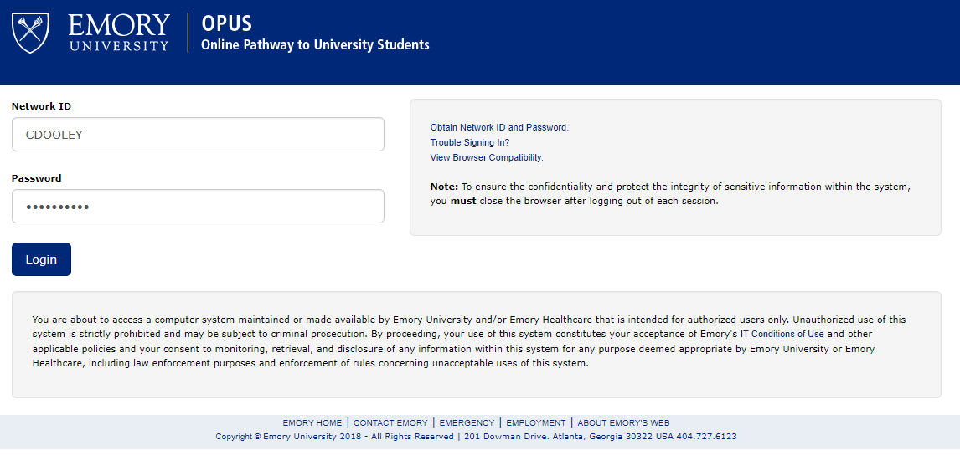

Step 2:
Click the Academic Progress Tile
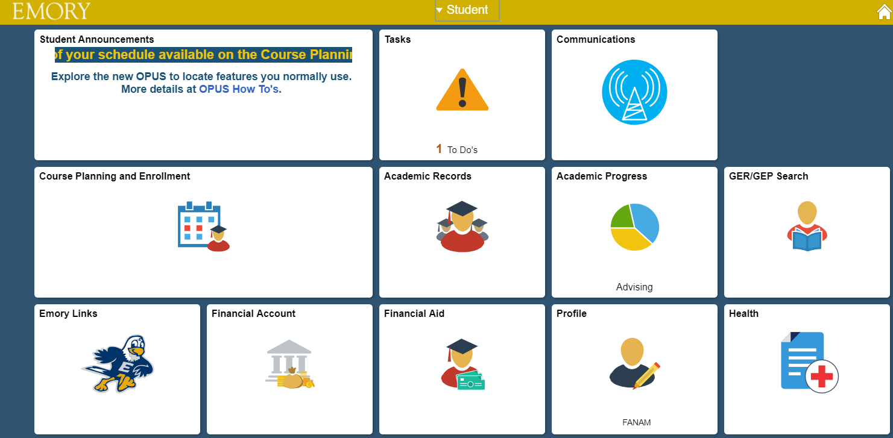
Step 3:
Click View What-If Report under Degree Audit
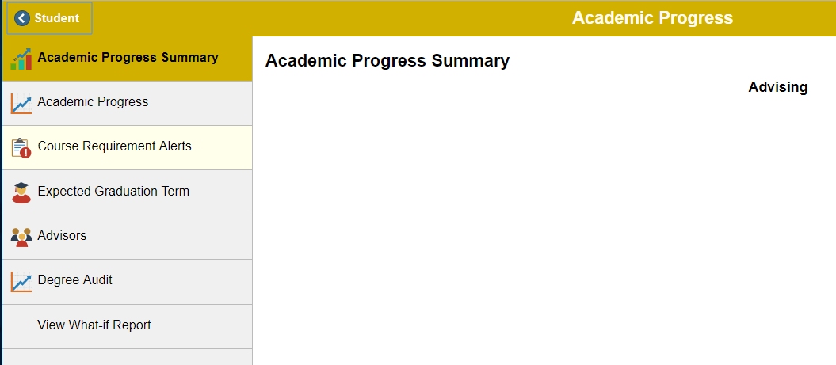

Step 4:
Click “Create New Report”
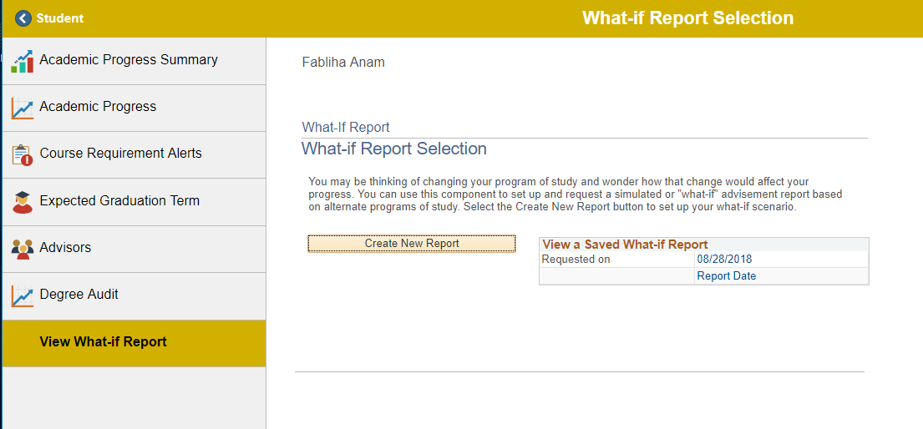

Step 5:
Select from “Career Scenario” drop down boxes to simulate alternate catalog years, majors or courses.
Click “Submit Request” to process report
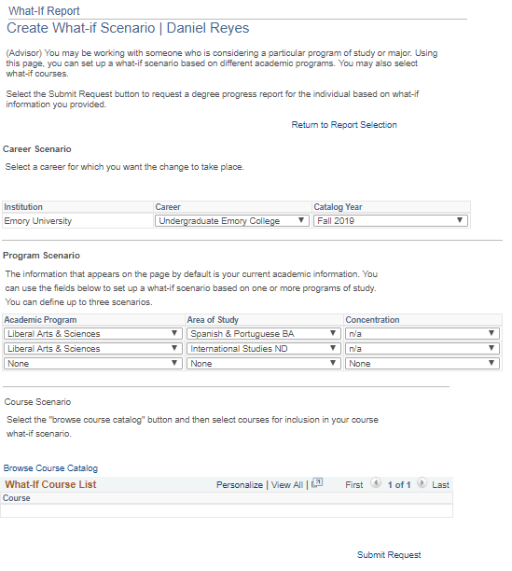
.
Timmy Dooley

Here is your Academic Advisement Report!
